WEEK 2- Mockito-Hands On-Exercises ___________________________________________________________________

**Exercise 1: Mocking and Stubbing**

**Scenario:** *You need to test a service that depends on an external API. Use Mockito to mock the external API and stub its methods.*

**Steps:**

1. *Create a mock object for the external API.*

*2. Stub the methods to return predefined values.*

*3. Write a test case that uses the mock object.*

**CODE:**

**MyService.java**

package com.example;

public class MyService {

private ExternalApi api;

public MyService(ExternalApi api) {

this.api = api;

}

public String fetchData() {

return api.getData();

}

}

**MyServiceTest.java**

package com.example;

import static org.mockito.Mockito.*;

import static org.junit.jupiter.api.Assertions.*;

import org.junit.jupiter.api.Test;

import org.mockito.Mockito;

public class MyServiceTest {

@Test

public void testExternalApi() {

ExternalApi mockApi = Mockito.mock(ExternalApi.class);

when(mockApi.getData()).thenReturn("Mock Data");

MyService service = new MyService(mockApi);

String result = service.fetchData();

assertEquals("Mock Data", result);

}

}

**ExternalApi.java**

package com.example;

public interface ExternalApi {

String getData();

}

**OUTPUT:**

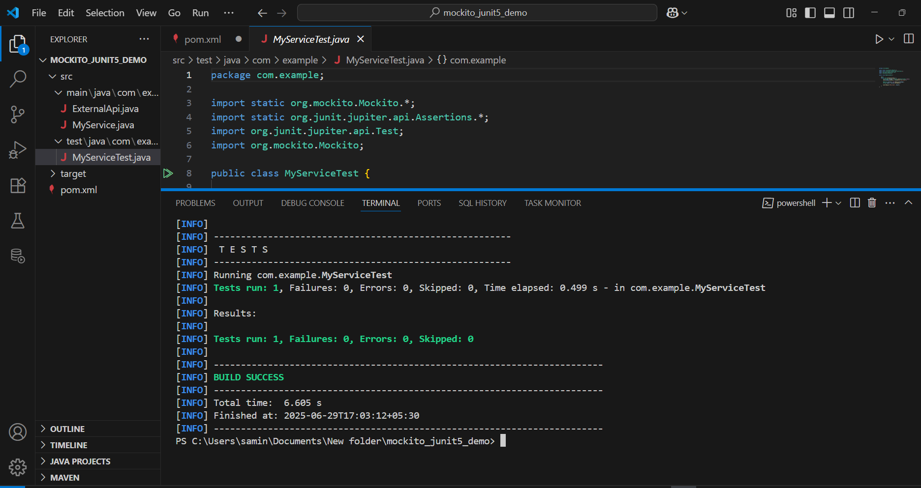

**Exercise 2: Verifying Interactions**

**Scenario:** *You need to ensure that a method is called with specific arguments.*

**Steps:**

1. *Create a mock object.*
2. *Call the method with specific arguments.*
3. *Verify the interaction.*

**CODE:**

**MyService.java**

package com.example;

public class MyService {

private ExternalApi api;

public MyService(ExternalApi api) {

this.api = api;

}

public void fetchData() {

api.getData();

}

}

**MyServiceTest.java**

package com.example;

import static org.mockito.Mockito.*;

import org.junit.jupiter.api.Test;

import org.mockito.Mockito;

public class MyServiceTest {

@Test

public void testVerifyInteraction() {

ExternalApi mockApi = Mockito.mock(ExternalApi.class);

MyService service = new MyService(mockApi);

System.out.println(" Calling FetchData()");

service.fetchData();

System.out.println(" Verifying Interaction......");

verify(mockApi).getData();

System.out.println(" Verification Passed!");

}

}

**OUTPUT:**

